**Practical no 21**

-- Step 1: Create Database

CREATE DATABASE CollegeDB;

USE CollegeDB;

-- Step 2: Create student Table

CREATE TABLE student (

roll_no INT PRIMARY KEY,

name VARCHAR(50),

department VARCHAR(50)

);

-- Step 3: Insert Sample Records

INSERT INTO student VALUES

(1, 'Yash', 'Computer'),

(2, 'Ritu', 'Electrical'),

(3, 'Tejas', 'Computer'),

(4, 'Amit', 'Civil'),

(5, 'Sneha', 'Computer');

-- Step 4: Create Stored Procedure with Cursor

DELIMITER $$

CREATE PROCEDURE DisplayComputerStudents()

BEGIN

-- Declare variables

DECLARE v_rollno INT;

DECLARE v_name VARCHAR(50);

DECLARE v_dept VARCHAR(50);

-- Declare condition variable

DECLARE done INT DEFAULT 0;

-- Declare cursor

DECLARE comp_cursor CURSOR FOR

SELECT roll_no, name, department

FROM student

WHERE department = 'Computer';

-- Handler for end of records

DECLARE CONTINUE HANDLER FOR NOT FOUND SET done = 1;

-- Open cursor

OPEN comp_cursor;

-- Loop to fetch and display data

read_loop: LOOP

FETCH comp_cursor INTO v_rollno, v_name, v_dept;

IF done = 1 THEN

LEAVE read_loop;

END IF;

SELECT CONCAT('Roll No: ', v_rollno,

' | Name: ', v_name,

' | Department: ', v_dept) AS StudentDetails;

END LOOP;

-- Close cursor

CLOSE comp_cursor;

END$$

DELIMITER ;

-- Step 5: Execute Procedure

CALL DisplayComputerStudents();

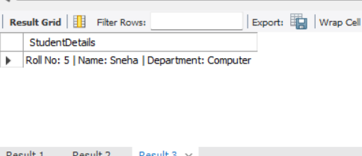

Q2.

DELIMITER $$

CREATE PROCEDURE DisplayEvenStudents()

BEGIN

DECLARE v_rollno INT;

DECLARE v_name VARCHAR(50);

DECLARE v_dept VARCHAR(50);

DECLARE done INT DEFAULT 0;

-- Cursor for even roll numbers

DECLARE even_cursor CURSOR FOR

SELECT roll_no, name, department

FROM student

WHERE MOD(roll_no, 2) = 0;

DECLARE CONTINUE HANDLER FOR NOT FOUND SET done = 1;

OPEN even_cursor;

read_loop: LOOP

FETCH even_cursor INTO v_rollno, v_name, v_dept;

IF done = 1 THEN

LEAVE read_loop;

END IF;

SELECT CONCAT('Roll No: ', v_rollno,

' | Name: ', v_name,

' | Department: ', v_dept) AS EvenStudentDetails;

END LOOP;

CLOSE even_cursor;

END$$

DELIMITER ;

-- Execute procedure

CALL DisplayEvenStudents();

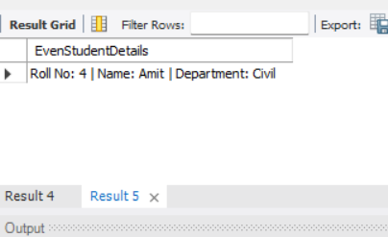

Q3.

CREATE TABLE store (

item_id INT PRIMARY KEY,

item_name VARCHAR(50),

price DECIMAL(10,2)

);

INSERT INTO store VALUES

(1, 'Laptop', 50000),

(2, 'Mouse', 500),

(3, 'Printer', 12000),

(4, 'Keyboard', 1500),

(5, 'Monitor', 20000);

DELIMITER $$

CREATE PROCEDURE CountExpensiveItems()

BEGIN

DECLARE v_item_id INT;

DECLARE v_item_name VARCHAR(50);

DECLARE v_price DECIMAL(10,2);

DECLARE done INT DEFAULT 0;

DECLARE v_count INT DEFAULT 0;

-- Cursor for items with price > 10000

DECLARE expensive_cursor CURSOR FOR

SELECT item_id, item_name, price

FROM store

WHERE price > 10000;

DECLARE CONTINUE HANDLER FOR NOT FOUND SET done = 1;

OPEN expensive_cursor;

read_loop: LOOP

FETCH expensive_cursor INTO v_item_id, v_item_name, v_price;

IF done = 1 THEN

LEAVE read_loop;

END IF;

SET v_count = v_count + 1;

END LOOP;

CLOSE expensive_cursor;

SELECT CONCAT('Number of items with price > 10000: ', v_count) AS ExpensiveItemCount;

END$$

DELIMITER ;

-- Execute procedure

CALL CountExpensiveItems();

